Group Name
and/or Logo

Project Assignment 1 – Requirements Analysis
(ITRW 321)

Group Members:
Group Leader: [12345678 – D. Liver]
[12345678 – I.P. Daly]
[12345678 – I. Lasch]
[12345678 – X. Benedict]
[12345678 – Dr. E. Ville]
[12345678 – Jo King]

Submission date: xx/xx/xx
Table of contents…

Description of group / database domain
In short, what is the focus of your organization / business / solution…

- Information needed for business decisions
  - Total sales figures of the company per financial year, per quarter, per month, etc…

  - Top sales executives per total sales, per new customers signed, per existing customers serviced, per year, per month, etc…

  - Best selling products, by quantity, sales revenue, per year, per month etc…

  - Average amount of overtime pay…

  - Verkope per produk, per streek, per agent, ens…

  - Totale verkope vir alle jare of slegs ŉ paar geselekteerde jare…

  - Verkope vir alle produkte of slegs ŉ paar geselekteerde produkte…

*For each of the business decision listed above...

1.4. Average amount of overtime pay
1.4.1. Description
Top management would like to view the average amount of overtime per province, per branch, per department, per year, per month, per week.

1.4.2. Organization level
Top level management (i.e. Financial, Logistics and IT managers) will view this report in order to make financial decisions with regards to departments of the company.

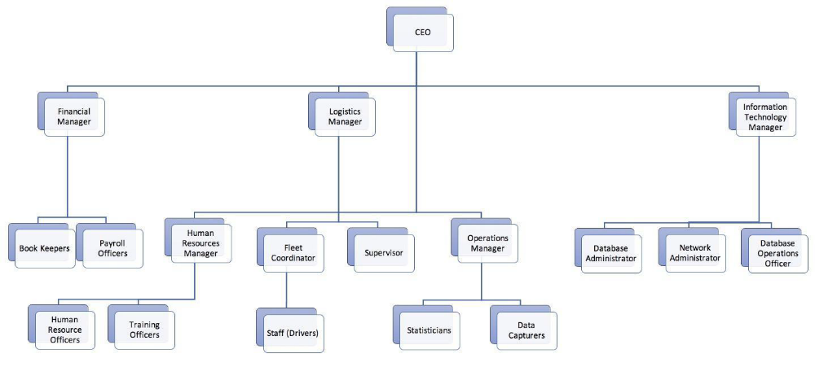

1.4.3. Business area
The Financial and Human resources departments will use this information and knowledge.

1.4.4. Format of information needed
A time period will be selected, i.e. a start year and an end year. A bar chart will show the average amount of overtime per province for the selected period. The next drill down level will show a column graph showing the average amount of overtime for each branch in the selected province for the selected period. When double clicking on a specific branch another column graph will show the average amount of overtime for each department of the involved branch for the selected period. When double clicking on a specific department a line graph will show the average amount of overtime for each department of the involved branch for every year in the selected period. By double clicking on a specific year another line graph per month will be shown. By double clicking on a specific month a line graph per week will be shown.

1.4.5. Timespan
The timespan involved is per year, per month, per week. The weekly average amount overtime per year, month or week will also be compared to the weekly amount overtime of previous years, months and weeks.

1.4.6. Aggregation and granularity
The average amount overtime pay will be calculated. Granularity will be as follows:
- Per province
- All branches in a specific province selected
- All departments of a specific branch selected
- All years in the selected time period
- All months for a specific year selected
- All weeks for a specific month selected

1.4.7. Dimensionality
- Province
- Branch
- Department
- Year
- Month
- Week

